Step 0 Source: Intake Result: Filing Status, Dependency
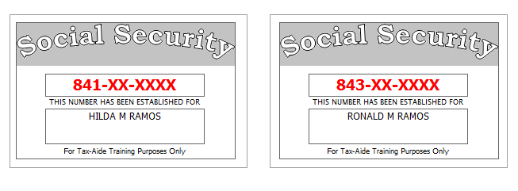
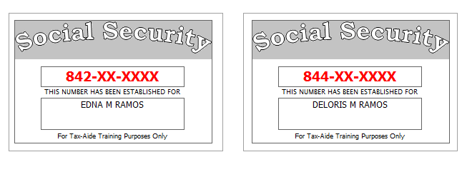
Hilda paid all household expenses and all support for her three children. No other person can claim any of the children as a dependent on their return.
Ronald is a full-time undergraduate student
Hilda’s husband, Sam, died on April 3rd 2012.
Reference: 4012 Tab A, B, C
Tool: IRS Interactive Tax Assistant (link on Preparer page)
Tool: AARP Resource Tool for Counselors (Laminated Flow Chart)
Tool: TP4F Qualifying Child/Qualifying Relative Flowchart Tool (link on Preparer page)
Tool: Dependent Calculator (link on Preparer page)

Step 1a Source: Intake Part I, II, VII TWO Screen: Main Info
Use the Filing Status and Dependency Status from Step 0
Refund Monitor
AGI | Refund | NJ 39 | NJ 56/66 | Notes
Hint: Ctrl-E to go to next red field
Hint: Don’t worry about RTN / DAN for direct deposit at this point.
Q: Did you put anything on % address line?
Step 1b Source: Intake Part I TWO Screen: NJ 1040 Pg1
Reference: NJ Special Handling p5
Tool: NJ Municipality Code Lookup Tool (link on Preparer page)
Tool: NJ 1040 Instructions – Municipality Code Table
Tool: TWO State Help
Refund Monitor
AGI | Refund | NJ 39 | NJ 56/66 | Notes
 |  |  |  | Hint: Use NJ Municipality Code Lookup Tool
Step 1c Source: Intake Part I, II TWO Screen: NJ 1040 Pg 2
Hilda wants to handle the Gubernatorial Election Campaign Fund the same way as the Presidential Election Campaign Fund.
Hilda and all dependents have health care coverage.
Reference: NJ Special Handling p5
Refund Monitor
AGI | Refund | NJ 39 | NJ 56/66 | Notes
Hint: Is there a dependent (under age 22) attending college?
Hint: Health care coverage – see Notes
Hint: Gubernatorial Elections Fund – see Notes
Step 1d Source: Intake Part VII TWO Screen: Prep Use
Refund Monitor
AGI | Refund | NJ 39 | NJ 56/66 | Notes
 |  |  |  | BP: Do not fill in line 14 until after QR
Step 2 Source: W-2 TWO Screen: W2 (SP)
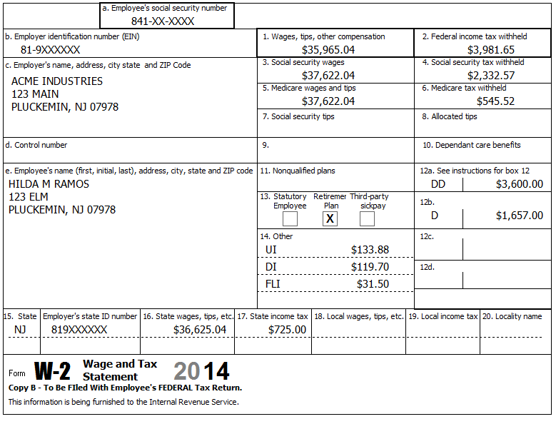
Hilda had dental insurance through her employer’s cafeteria plan which cost her $55 per month. It was pre-tax for federal and after-tax for NJ.
Refund Monitor
AGI | Refund | NJ 39 | NJ 56/66 | Notes
35,965 | 5,843 | 31,125 | 578 | Hint: Do not need to override 3, 4, 5, 6  BP: Handle NJ after-tax insurance later  Check: Sch A, Line 5a = 1,011
Step 3 Source: 1099-INT TWO Screen: Interest Stmt
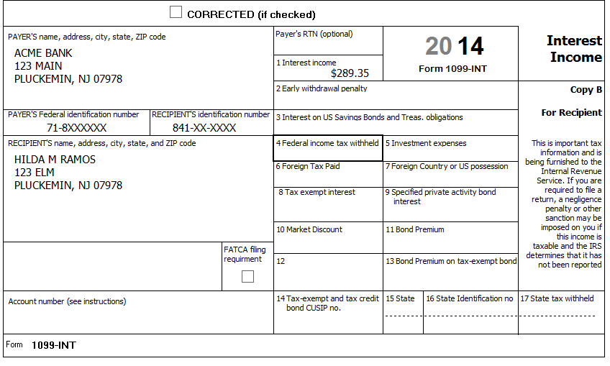
Reference: 4012 D-9
Refund Monitor
AGI | Refund | NJ 39 | NJ 56/66 | Notes
36,254 | 5,749 | 31,414 | 560 | Hint: Interest Stmt worksheet is under Sch B in the tree
Step 4 Source: W2-G TWO Screen: W2G
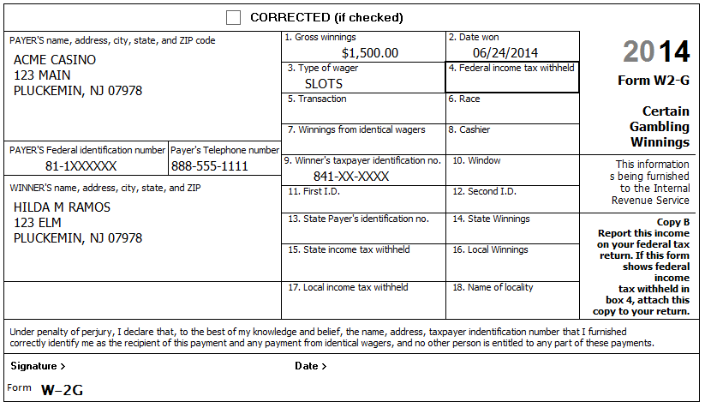
Hilda had gambling losses of $2,000.
Reference: NJ Special Handling p3
Refund Monitor
AGI | Refund | NJ 39 | NJ 56/66 | Notes
37,754 | 5,284 | 31,414 | 497 | Hint: Need to add W2G (if not in tree)  BP: Include appropriate losses directly on W2G (bottom right)  Check: Sch A, line 28 = 1,500  Check: NJ 1040, line 23 = 0
Step 5 Source: 1099-G TWO Screen: 1099G Wkt
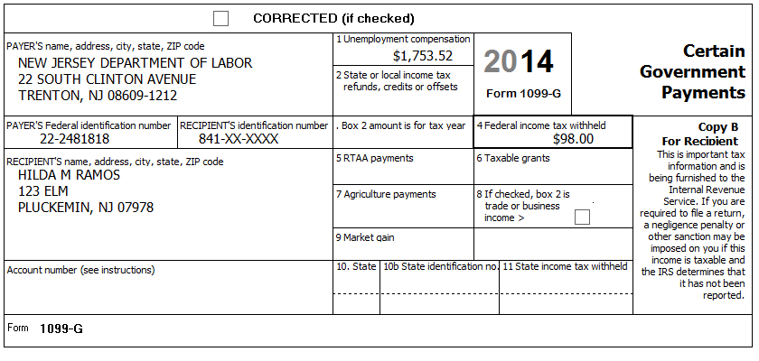
NJ no longer sends out paper 1099-G forms for unemployment
Refund Monitor
AGI | Refund | NJ 39 | NJ 56/66 | Notes
39,508 | 4,838 | 31,414 | 423 | Hint: 1099G Wkt probably already in tree with NJ info filled in

Step 6a Source: 1099-R TWO Screen: 1099R
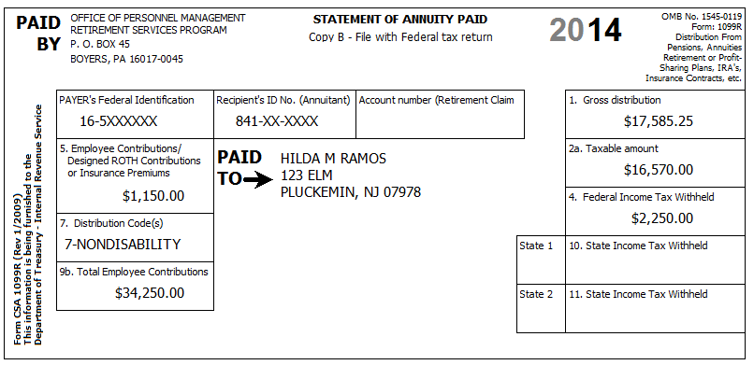
4-Death
Hilda’s husband, Sam, was a federal employee at the time of his death, and Hilda was able to start drawing his joint/survivor annuity in January of the prior year. (She elected to not use the NJ three-year rule.)
Reference: 4012 D-20, D-21, D-26 (2: Form CSA 1099-R…)
Reference: NJ Special Handling p3
Refund Monitor
AGI | Refund | NJ 39 | NJ 56/66 | Notes
56,078 | 4,056 | 47,984 | (45) | Check: NJ 1040, line 19a = 16,570; line 19b = 0
Step 6b Source: 1099R TWO Screen: A Detail
Reference: 4012 D26 2: Form CSA 1099-R
Refund Monitor
AGI | Refund | NJ 39 | NJ 56/66 | Notes
56,078 | 4,056 | 47,904 | (44)

Step 6c Source: 1099R TWO Screen: NJ 1040 Pg 2, Line 19b
Reference: NJ Special Handling p5
Refund Monitor
AGI | Refund | NJ 39 | NJ 56/66 | Notes
56,078 | 4,056 | 47,904 | (44) | Hint: Follow procedure in NJ Special Handling for NJ 1040 Pg 2, Line 19b (Excludable pensions)  Check: NJ 1040, line 19b = 1,015  Check: NJ 1040, line 19a (16,570) + line 19b (1,015) = 17,585

Step 7a Source: 1099-R TWO Screen: 1099R
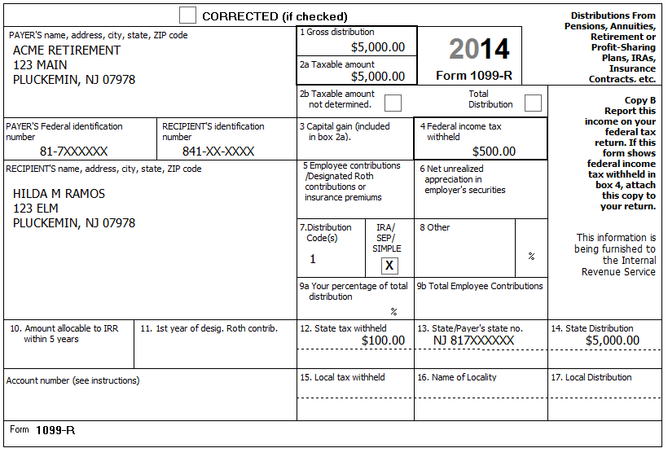
To help pay for Ronald’s education, Hilda took an early distribution from her IRA account.
Reference: 4012 D-20, D-21
Refund Monitor
AGI | Refund | NJ 39 | NJ 56/66 | Notes
61,078 | 3,306 | 47,904 | 56 | Check: NJ 1040 Pg 3, Line 48 = 825
Step 7b Source: Notes TWO Screen: 5329 TP 1
Reference: 4012 H-1, H-2
Refund Monitor
AGI | Refund | NJ 39 | NJ 56/66 | Notes
61,078 | 3,806 | 47,904 | 56 | Hint: 5329 TP 1 should have popped into tree automatically  Hint: Use Reference, above, to look up exception code  Check: 1040 Pg 2, Line 59 = 0

Step 7c Source: Notes TWO Screen: NJ IRA Wkt
Hilda has records that indicate the value of her IRA on 12-31 was $45,000. Her total previously taxed contributions is $20,000. This is her first withdrawal from this IRA. (Note: having record of contributions is very rare.)
Reference: NJ Special Handling p7
Refund Monitor
AGI | Refund | NJ 39 | NJ 56/66 | Notes
61,078 | 3,806 | 50,964 | (4) | Check: NJ 1040, line 19a = 19,570; 19b = 3,015
Step 8 Source: Notes TWO Screen: 1040 Wkt2
Hilda is repaying a student loan and received a statement from the lending institution showing that she had paid $385.67 in interest last year.
Reference: 4012 E-4, E-5
Refund Monitor
AGI | Refund | NJ 39 | NJ 56/66 | Notes
60,692 | 3,866 | 50,964 | (4) | Hint: May need to add 1040 Wkt2 manually
Step 9a Source: Notes TWO Screen: 1040 Pg 1
Hilda did not itemize deductions last year.
Refund Monitor
AGI | Refund | NJ 39 | NJ 56/66 | Notes
60,692 | 3,866 | 50,964 | (4)
Step 9b Source: Notes TWO Screen: Sch EIC
Probably still red in tree (ignore this sub-step if Sch EIC is not red)…
Refund Monitor
AGI | Refund | NJ 39 | NJ 56/66 | Notes
60,692 | 3,866 | 50,964 | (4) | Hint: Answer questions in order and only if red
Step 10 Source: W-2 TWO Screen: NJ 1040 Pg 2, Line 30
The 660 of NJ after-tax medical can be added now that NJ 1040 Line 28 is finalized.
Reference: NJ Special Handling p6
Refund Monitor
AGI | Refund | NJ 39 | NJ 56/66 | Notes
60,692 | 3,866 | 50,304 | 12 | BP: Use Scratch pad attached to NJ 1040 Pg 2, Line 30 to document handling of after-tax Medical
Step 11 Source: Notes TWO Screen: NJ 1040 Pg 3, Line 45
Hilda did not make any out of state purchases on which she would owe Use Tax.
Reference: NJ 1040 Instructions or link to Use Tax table on Preparer page
Refund Monitor
AGI | Refund | NJ 39 | NJ 56/66 | Notes
60,692 | 3,866 | 50,304 | 12 | Hint: Just un-red line 45
Step 12 Source: Notes TWO Screen: NJ 1040 Pg 3, Worksheet F
Hilda was a tenant all year. Her rent was $800 per month.
Reference: NJ Special Handling p12
Refund Monitor
AGI | Refund | NJ 39 | NJ 56/66 | Notes
60,692 | 3,866 | 50,304 | 62
Step 13 Source: Notes TWO Screen:
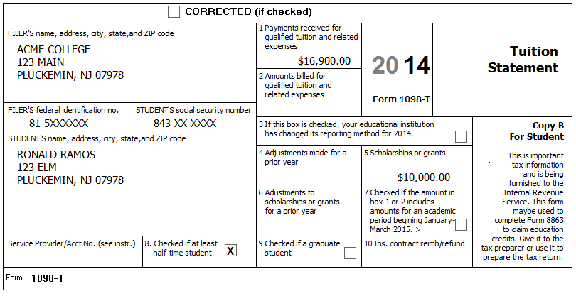
In order to accurately evaluate alternative ways to claim education deductions/credits we wait until the rest of the return is finished.
Ronald is a full-time undergraduate student. He started attending college three years ago last August. Ronald’s grandmother made the payments for his tuition and fees (no room & board) directly to the university. (To be safe, you confirm that the 1098-T from the University agrees with the payments actually made: $16,900 total to school = $6,900 out-of-pocket plus $10,000 scholarship.) Ronald did not receive a 1098-T for 2013 with any entry in box 2. Ronald does not have a felony controlled substance conviction.
Reference: 4012 J-1 thru J-8, EXT-2
Step 13a Source: Notes TWO Screen: Diagnostics
We are going to compare several alternative ways of handling the education costs.
Refund Monitor
AGI | Refund | NJ 39 | NJ 56/66 | Notes
60,692 | 3,866 | 50,304 | 62 | BP: Run Diagnostics and fix any errors before proceeding
Step 13b Source: Notes TWO Screen: 1040 Wkt2
Try education expenses as a Tuition and Fees AGI Deduction first.
Refund Monitor
AGI | Refund | NJ 39 | NJ 56/66 | Notes
56,692 | 4,466 | 50,304 | 62
Step 13c Source: Notes TWO Screen: 8863 Pg 2
We will try education expenses as a Lifetime Learning Credit next.
Refund Monitor
AGI | Refund | NJ 39 | NJ 56/66 | Notes
60,692 | 4,323 | 50,304 | 62 | Hint: Need to add 8863 Pg 2 to tree (Note: not 8863 Pg 1 – 8863 Pg 1 will pop into the tree as soon as start to fill in Pg 2)  Result: AGI Deduction better than Lifetime Learning credit  Q: Why is AGI Deduction better than Lifetime Learning credit?
Step 13d Source: Notes TWO Screen: 8863 Pg 2
Try education expenses as an American Opportunity Credit next.
Refund Monitor
AGI | Refund | NJ 39 | NJ 56/66 | Notes
60,692 | 6,366 | 50,304 | 62 | BP: Use Scratch Pad linked to 8863 Pg 2, Line 27 to document breakdown of expenses and adjustment to get to 4,000 limit  Result: American Opportunity Credit is best result
Step 14 Source: Notes TWO Screen: 1040 ACA Wkt
Everyone had MEC all year and no one had Marketplace coverage.
Reference: 4012 ACA Tab
Reference: ACA TaxWise Procedures (TY2014 version)
Refund Monitor
AGI | Refund | NJ 39 | NJ 56/66 | Notes
60,692 | 6,366 | 50,304 | 62 | Hint: Everyone marked as Full
Step 15 Source: Notes TWO Screen: Diagnostics
Run Diagnostics – Resolve any issues before handling refund / amount due
Step 16 Source: Notes TWO Screen: NJ DD Wkt
Hilda would like any NJ refund or amount due to be handled the same way as for her federal return.
Refund Monitor
AGI | Refund | NJ 39 | NJ 56/66 | Notes
60,692 | 6,366 | 50,304 | 62 | Hint: Read options under Direct Deposit and select appropriate one
Step 17 Source: Notes TWO Screen: Diagnostics
Run Diagnostics (and Create e-File) – Resolve any issues
For a client return, the next step would be Quality Review…

